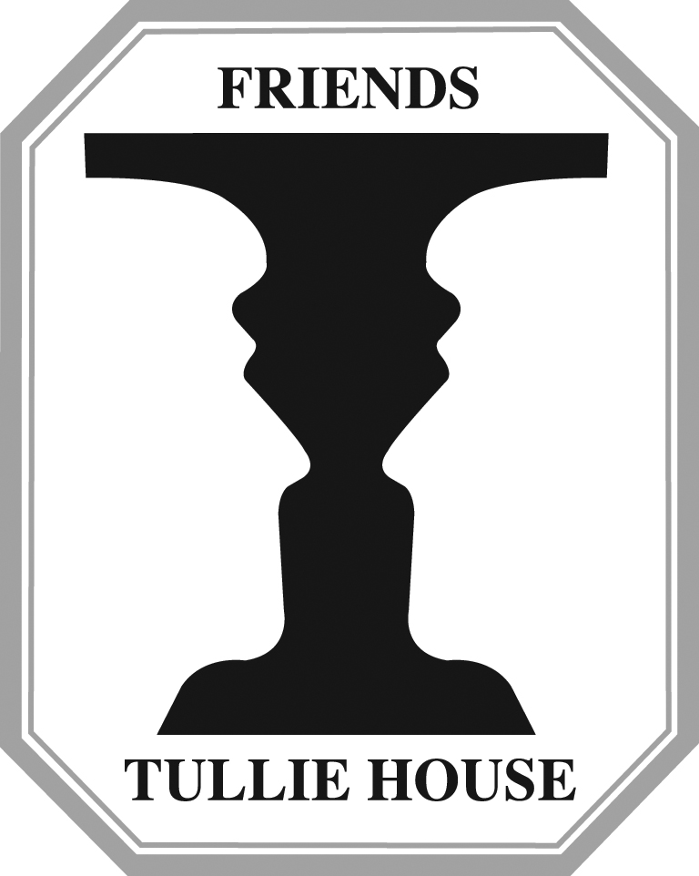

Chairman: Mr Richard Spiers, Treasurer: Barbara Eden,
Eden Holme, 89 Broad Street,
Wetheral, Carlisle,
Carlisle, Cumbria,
CA4 8ES CA1 2AQ

Reg. Charity No.: 1066547

Donations to the Friends of Tullie House to go towards the purchase of the
Crosby Garrett Roman Helmet

In the event of a failure at auction or cheaper purchase, Friends of Tullie House will use the money raised for its charitable purposes to support future acquisitions or conservation of existing Tullie House collections. If you do not agree, please tick

Contributor Information
Name
Address
Postcode
Telephone Number(s)
E-Mail Address

Donation

Amount to donate (figures) |  |  | £
Amount to donate (text)
Method of Payment (Please tick)
Cheque – Made payable to ‘Friends of Tullie House’
Credit Card
Card Type (Please Circle) : MasterCard / Visa / Maestro / Solo / Electron
Card Number
Expiry Date |  |  |  | Security Code (last 3 no’s on signature strip)
Valid from or Issue No. (Maestro / Solo cards only)

For every £1 donated, an extra 28p can be re-claimed from tax paid to the Inland Revenue. Therefore, your donation can be worth over 25% more with no additional cost to you.

I would like to Gift Aid my donation (please tick)

Signed
Date

